Assignment 3
Yan Li @ 04172015
Chapter 6 problem 5
b) i) Forecast the validation period Quarter 21- 22 using the training data set.
Forecast
 | Quarter | Forecast | LCI | UCI
 | 21 | 60847.97 | 55603.43 | 66092.51
 | 22 | 62487.87 | 57101.99 | 67873.76
 | 23 | 72125.26 | 65908.72 | 78341.8
 | 24 | 95491.26 | 87260.78 | 103721.7
ii) Calculate MAPE for multiplicative Holt-Winter’s and Regression model:
MAPE for Holt-Winter’s:
Quarter
Actual | Forecast | Error | abs(et/yt)
21 | 60800 | 60847.97 | -47.9659 | 0.000789
22 | 64900 | 62476.69 | 2423.308 | 0.037339
23 | 76997 | 72745.84 | 4251.163 | 0.055212
24 | 103337 | 97686.39 | 5650.61 | 0.054681
 |  |  | MAPE = | 3.700536%

MAPE for Regression Forecast:
Quarter | Actual | Regression Forecast | Error | abs(et/yt)
21 | 60800 | 58793.71 | 2006.294 | 0.032998
22 | 64900 | 60951.51 | 3948.495 | 0.06084
23 | 76997 | 70920.07 | 6076.927 | 0.078924
24 | 103337 | 93788.63 | 9548.373 | 0.0924
 |  |  | MAPE = | 6.629062%

c) Holt-Winter’s exponential smoothing method has lower MAPE than regression, which means it has smaller deviation on average. However the forecast plot of regression fits better to the actual plot. Holt- Winters has bigger deviations along the time but are averaged out overall. What’s more, the residual plot of regression has smaller curve, meaning trend was taken care better and the forecast has smaller deviations from the actual values.
d) The order is not important. You can do de-trend first or de-seasonality first then do the other one.
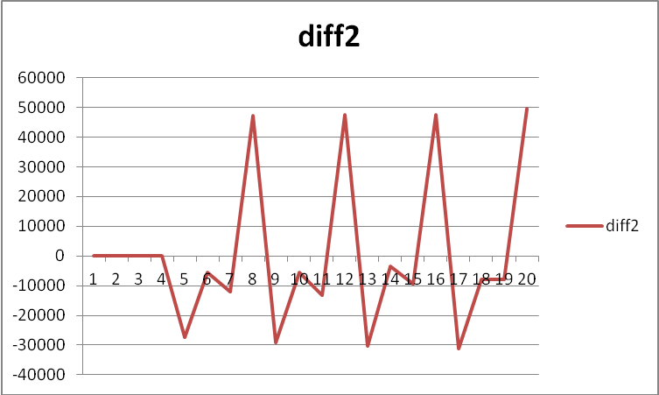
e)
Quarter | Actual | Forecast
21 | 60800 | 96380.5
22 | 64900 | 108407
f) The exponential smoothing is much better.
The exponential smoothing forecast error is much less.
21 | 60800 | 60847.97 | -47.9659
22 | 64900 | 62476.69 | 2423.308

The differencing has larger error:  Quarter | Actual | Forecast |  | Forecast Error
21 | 60800 | 96380.5 |  | 35580.5
22 | 64900 | 108407 |  | 43507
Differencing is based on historical data and is not good to predict the future values.
g) Naive forecasting could be an even simpler approach considered as a baseline.

Chapter 6 Problem 8:
a) All plots show similar seasonal patterns but show different trend: increasing trend, decreasing trend and no trend. Exponential smoothing will be good to fit all. Moving average will require de-trend and de-seasonality. The same Regression model is hard to fit all six series.
b) Multiplicative Holt-Winter’s Exponential Smoothing on Fortified Wine is attached in the Excel Sheet.
c)
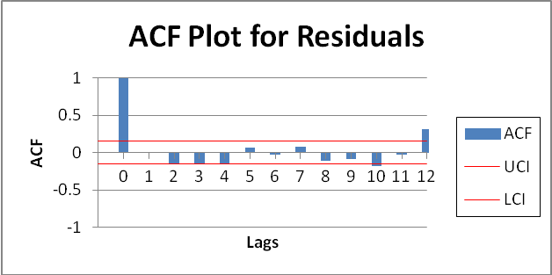
The following comments are right:
December (month12) are not captured well by the model.
We should try to fit a lag-12 autoregression model on the residuals.

